In virtual machine (ubuntu):

# sudo apt update

# sudo apt upgrade

# sudo apt install openssh-server

# sudo systemctl status ssh

# sudo service ssh start

# sudo systemctl status ssh

# sudo ufw allow ssh

# sudo ufw enable

# sudo ufw status

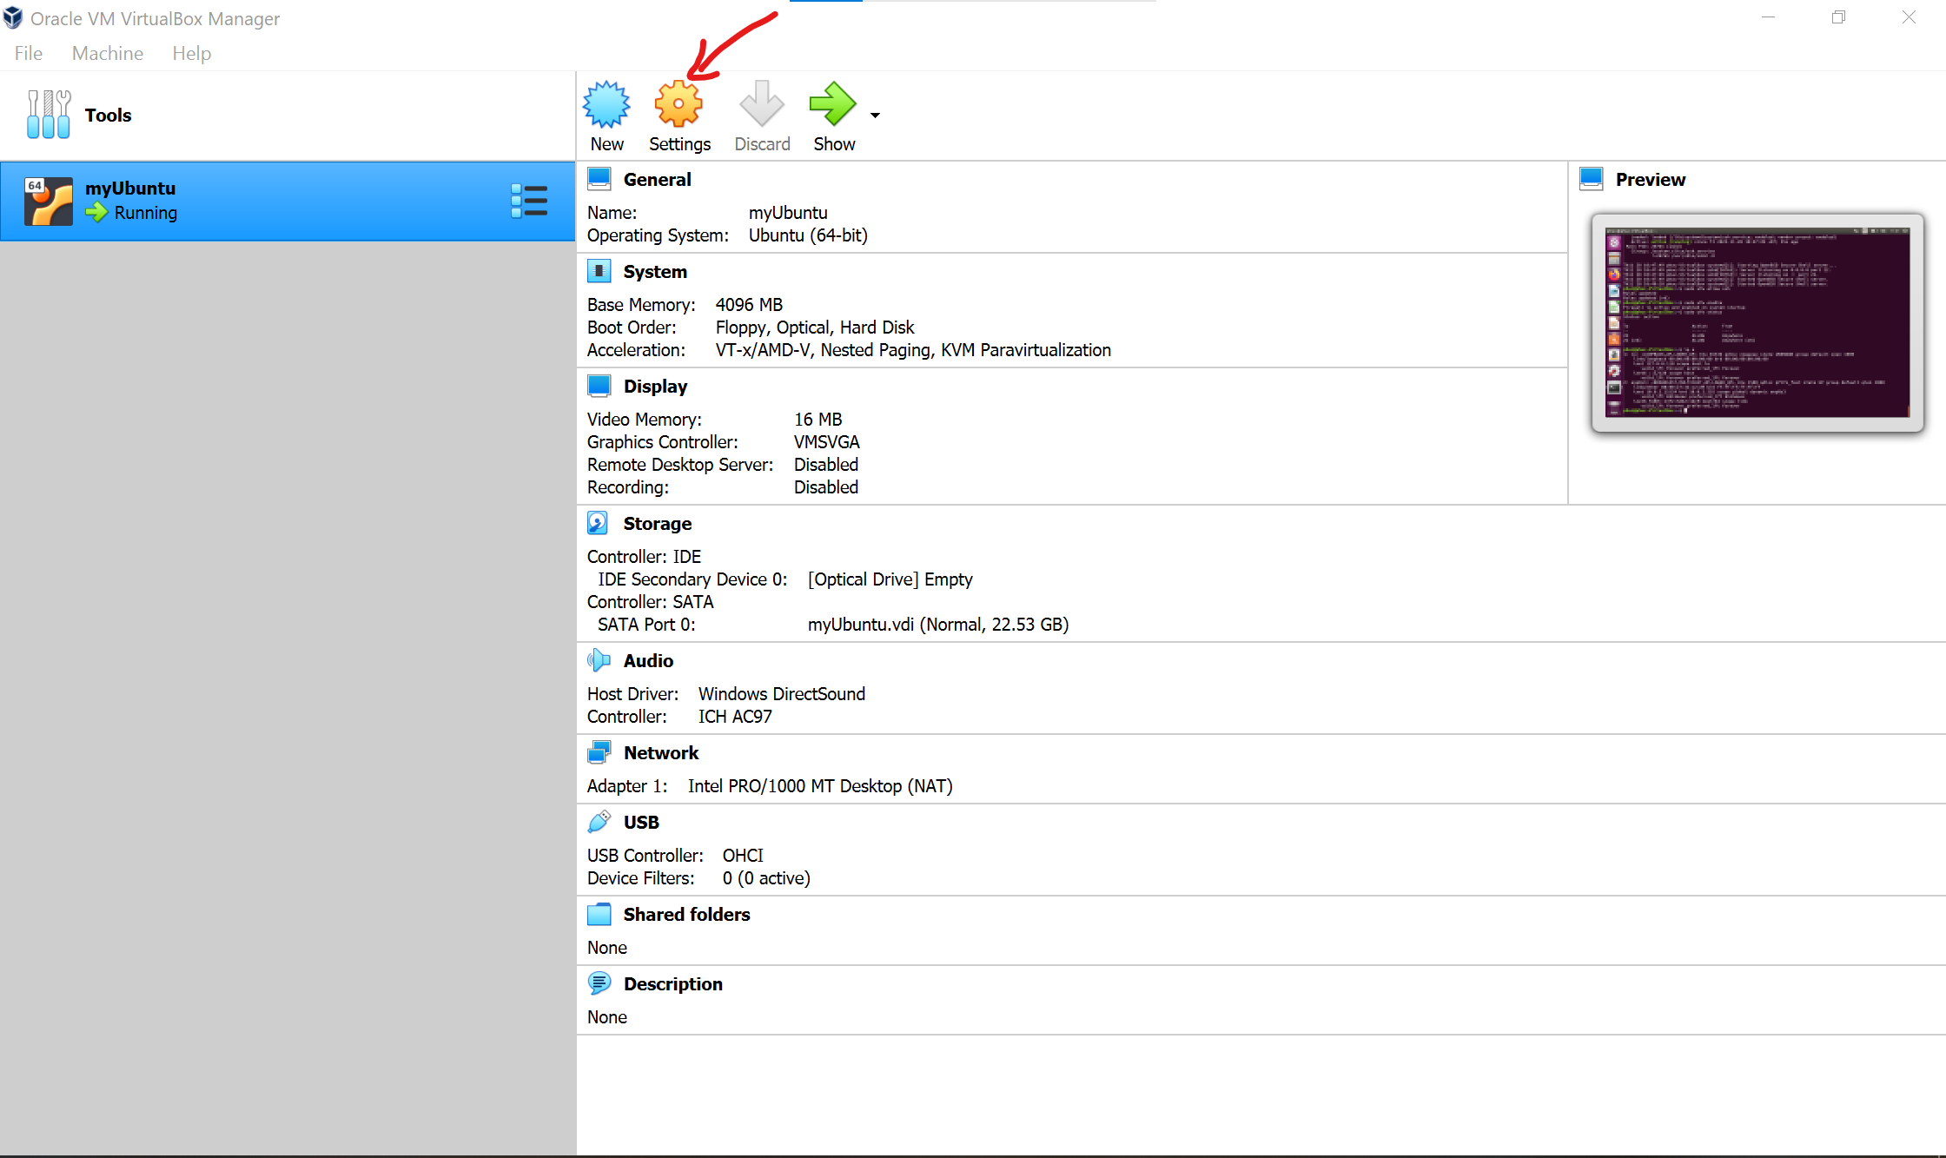

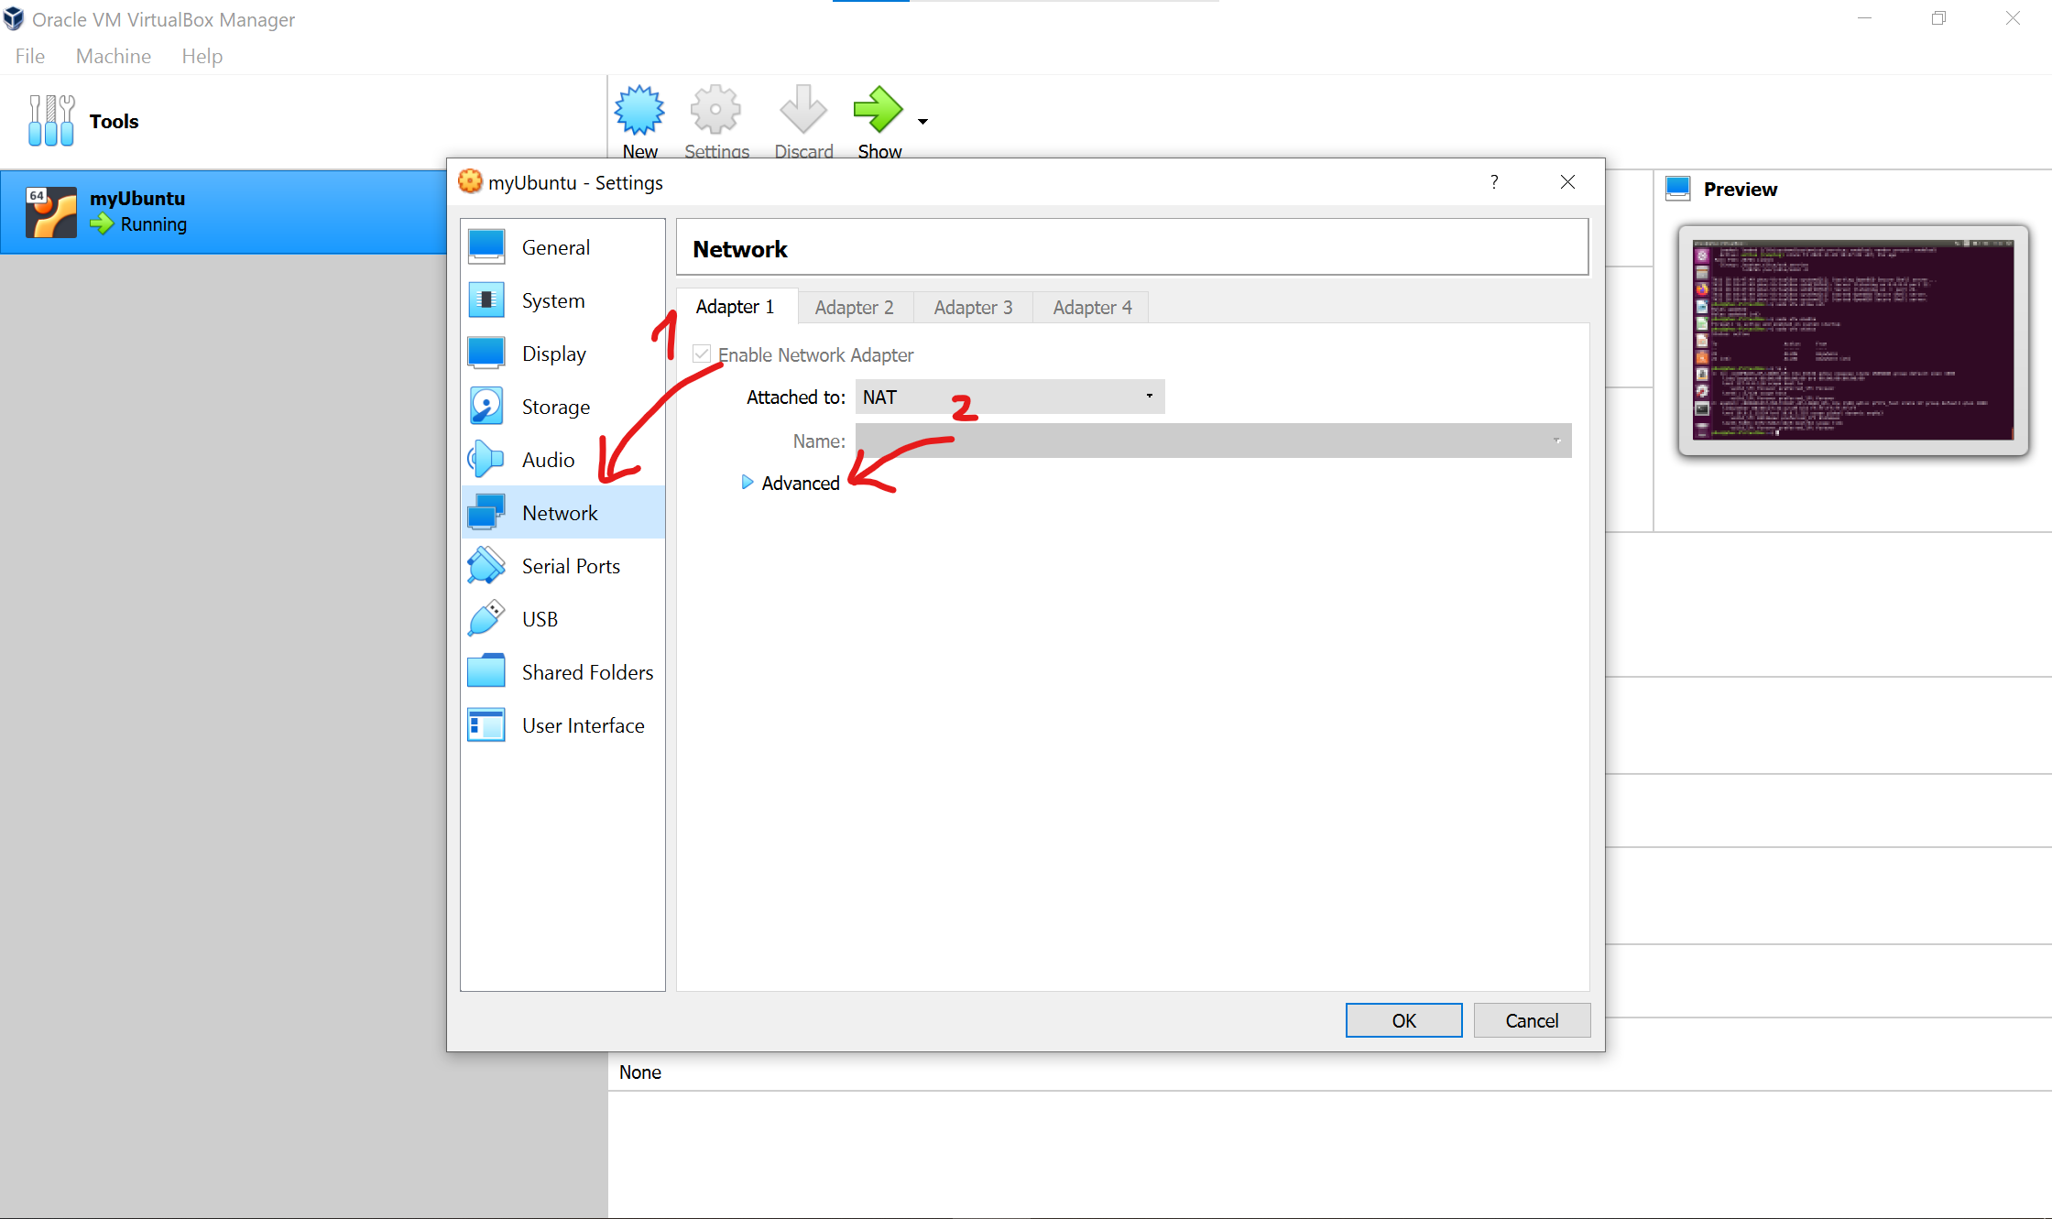

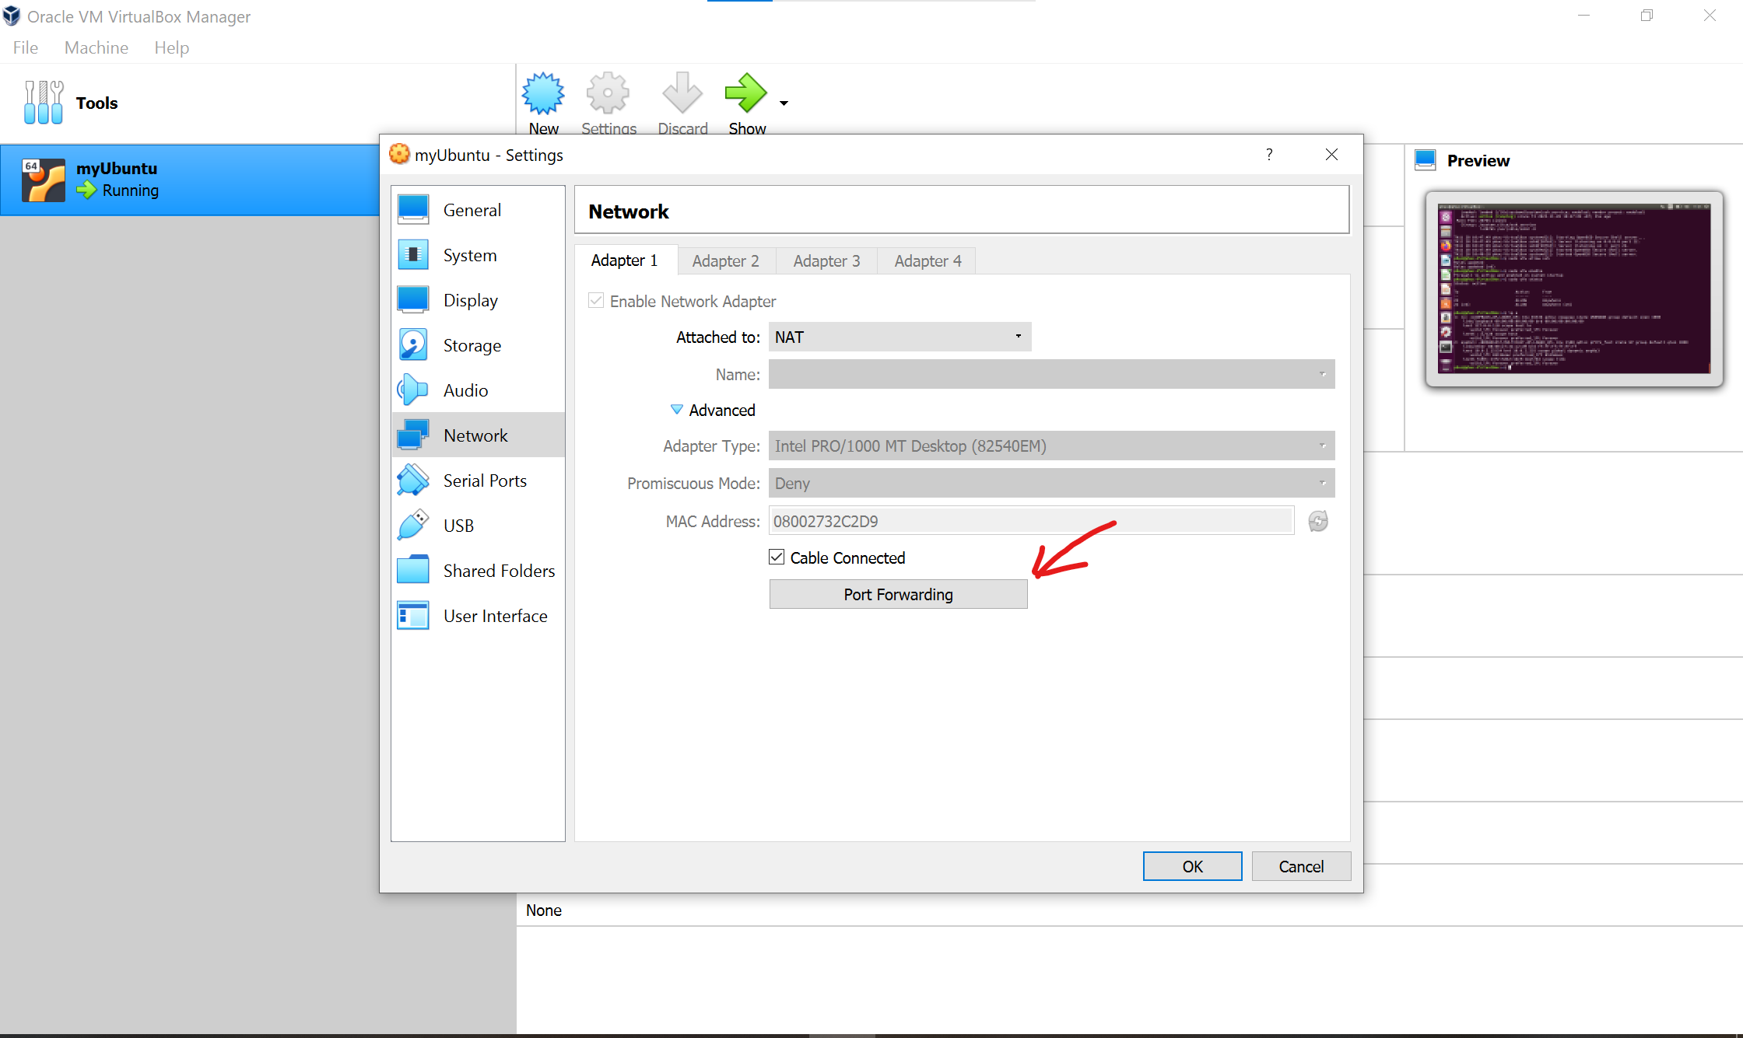

Click the green plus icon

Input data fields as below, notice that the Guest IP is the virtual machine’s IP (check at the virtual machine by command **ip a** or **ifconfig**)

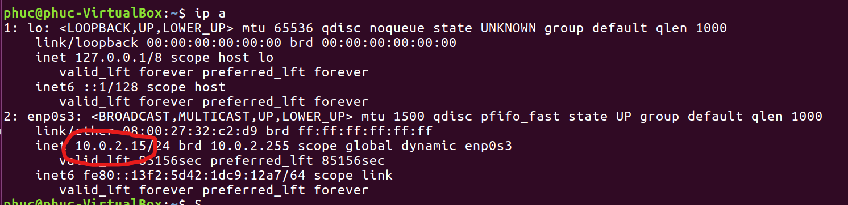

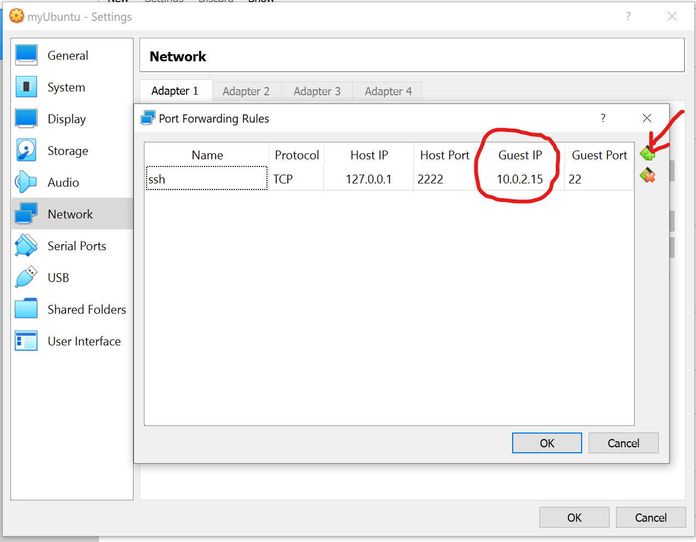

Press OK button and save all configurations.

=> Open Command Prompt, Moba Xterm or VSCode with ssh extension, type command

**# ssh** **-p** 2222 [<user>**@127**.0.0.1](mailto:<user>@127.0.0.1)

or # **ssh** **-p** 2222 <user>**@localhost**

